
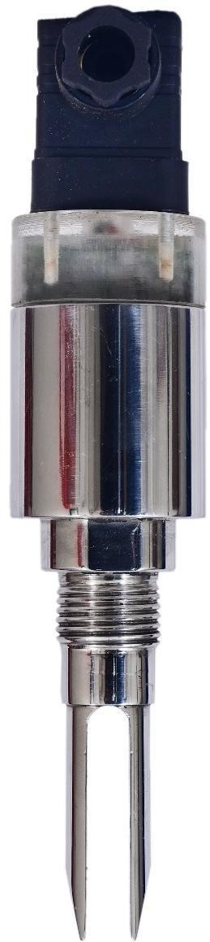
MINIATURE VIBRATING FORK is specially designed for detecting maximum and minimum level in tanks/ vessels filled with LIQUID media.

Minia tur e FORK can be used for detecting the level of liquid having overall Sp. gravity ranging from 0.785 to
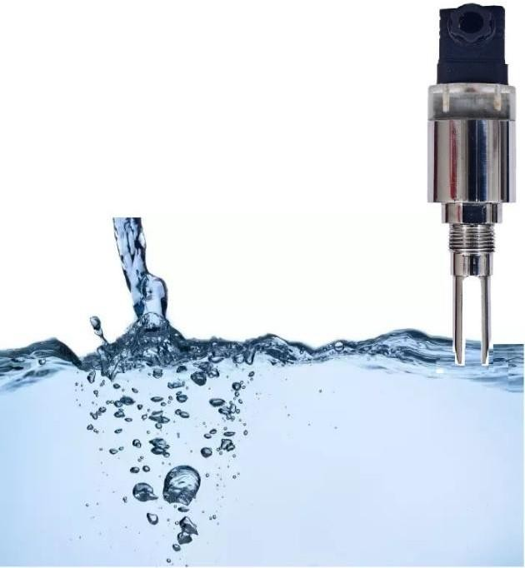
1.5 Variation of electrical parameters of the service material such as conductivity and dielectric constant do not affect its operation. It can be used successfully for level detection of various liquids, chemicals, epoxy, resins, water-based liquids, petrochemicals etc.

Operating Principle:
The Tuning Fork is kept vibrating at its mechanical resonant frequency by Piezo elements. When the liquid media covers the tines, it resists its movement and so the vibrations are damped. The damped vibrations are sensed electrically and the signal is
processed to signal an alarm and or control a relay. External relay contacts can be used to control the feed motor or evacuation valve etc

Salient Features:
- Compact size with integral electronics
- Easy Calibration Procedure,
- No moving parts so no wear and tear
- 24 V DC Power supply
- Standard PNP outputs available
- Short fork design @68 mm for minimum insertion in small tanks.
- Available in ½” BSP/NPT/flanged/screwed mounting
- LED indicators for status, normal & Alarm conditions.

Technical Specifications:
Housing: SS -304
TYPE: Integral with probe with Electronics
Cable Entry: PG 9
Cable Gland: Single compression PG 9
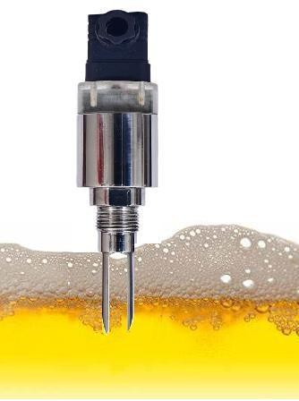
Mounting: ½” to ”1" OR 1 & 1/2'” BSP / NPT /Flanged Pipe extension: SS304 /SS316 as per requirement Tuning Fork: S316/SS304

Power supply: 24 VDC (12 to 30 V DC)
Power consumption: 2 VA Max. Out Put: Open Collector PNP
Open collector transistor: PNP output as standard, current limited to 200mA
Resonant frequency of fork: 2000 Hz approx.
Sensitivity: Field selectable for Low, medium and High- density liquids/ fluids

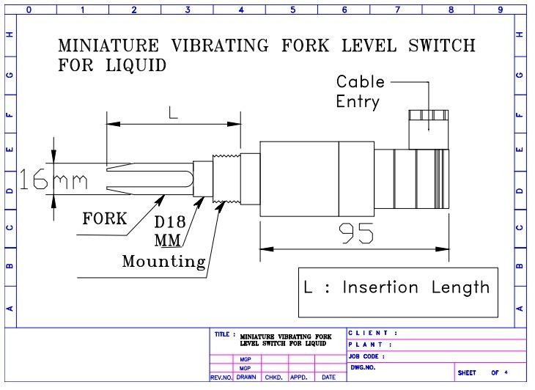
Mechanical Drawing:

